Subject: Recuperative & Post Surgical Care Quotation

Dear Ellen,

Thank you so much for speaking with me yesterday afternoon, and as promise here is more information about Keep Safe Care – Central Austin, a licensed Texas Health Care Services & Support Agency and how we can help you post discharge with our Keep Safe Recuperate service.

Part of our service includes having a team available as your recuperate and gain your mobility. Usually, this involves 2 to 3 nights of overnight care, as well as full daytime care. Usually, the overnight care is reduced and clients move to 12 hours, 8 hours, and then 4 hour stays until completely recuperated. It sounds like you have the first couple of days of overnights covered. Typically, this recuperation period is from 3 to 9 weeks. Something to note: Our caregivers are CNAs and we pay them 2/3s of whatever our charge for care would be. This guarantees consistent care with the same caregivers during your recovery.

This recuperation service also includes delivering clients to medical facilities (if you need a ride), waiting for you during the procedure and returning you home post procedure.

Based on the duration and requirements, our rate is $33 per hour plus a $10 trip fee that goes 100% to the caregiver.

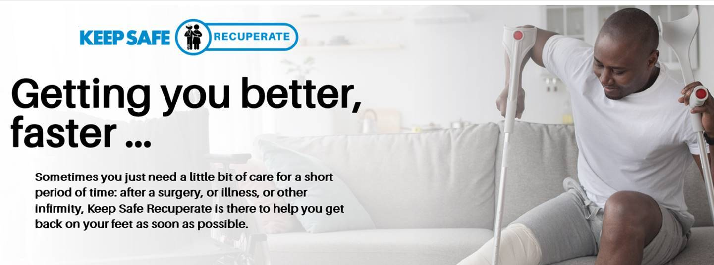

Please feel free to contact me if you have any questions, I and will get back with you over the weekend just in case. I will also be sure to giver Elizabeth at Advanced Home Healthcare a thank you for the referral.

Sincerely,
Jeffrey

Jeffrey Fry
Owner / Operator
Keep Safe Care – Central Austin
TX HCSSA License #019800
+ jxf@keepsafecare.com
È(512) 632-3080 (m) ( (512) 766-0150 (o)

The next level of Caregiving

