
supplies and merchandise
Supplies an Affiliate should have on hand for operations and hand out




December 7, 2024
keep safe care corporation

Contents
Summary 3
Supplier Contacts 3
UPrinting 3
Bat City Awards 3
Totally Promotional 3
Amazon 3
Printed Materials 4
Promotional Items and Office Supplies 5
Engraved Flash Lights with carabiner 5
White Metal Logo Pens 6
Dry Erase Magnetic Sheets 6
Cutting Instructions for Dry Erase Sheets 7
Dry Erase Markers 7
Printed Keep Safe Care Coffee Mugs 8
Avery Two Pocket Folders (Dark Blue & Black) 9
White or Blue Paper Bags 10
Metal (Aluminum) Etched Name Badges 11
Owner / Operator Badge 11
Certified Nursing Assistants (CNAs) Badge 11
Personal Care Attendants (PCAs) Badge 11
Embroidered Items 12
Miscellaneous Embroideries 12
Embroidered Polo Top 13
Embroidered Cap (Black) 13

Summary
This document outlines the merchandise an Affiliate should purchase to conduct proper marketing and brand recognition of a Keep Safe Care Private Duty Agency. All items will include items, source, and URLs for purchasing.
This document is divided into three sections. The first is Printed Materials which will be ordered prior to operations. Second is Promotional Items and Office Supplies, and the last section is Embroidered Items.

Supplier Contacts
Below is a listing of the suppliers listing in this document. Details on which items to be purchased are contained in this document.

UPrinting
Your UPrinting account should have been set up by Corporate and your original order placed upon opening. The UPrinting URL is www.uprinting.com.

Bat City Awards
Bat City Awards provides most of our promotional items as well as all our embroidered pieces as well. They are a family run business in downtown Austin and have always be super responsive and fairly good with their pricing. You can contact that either through email at Sales@batcity.com or via phone at (512) 302-1212. The company’s website is located at www.batcity.com.

Totally Promotional
Totally Promotional only produces our metal pens. To contact them send an email to customerservice@totallypromotional.com and tell them you want to order the Keep Safe Care pens as listed in this document.

Amazon
This is just amazon.com. You will need to create your own account on Amazon and make sure you use your business credit card. Many of our supplies can be acquired there.

Printed Materials
The printed materials below should have been ordered through your UPrinting account set up by Corporate. If you have not received your UPrinting credentials, please contact Keep Safe Care to obtain them. Your account should be set up as a “Trade Account” allowing you 10% off all printed orders.
The table below outlines what your initial purchase of marketing and printed materials should consist of. Also, please see Corporate for the design of your initial set of business cards and other location specific materials.

Start Up Printed Materials Quantities

Item | Qty | Ordered | Arrived
Brochures (Trifolds) | 1,000
Business Cards (owners, each) | 1,000
Labels (Keep Safe Care) | 500
Labels for Whiteboard Magnets | 50
Differentiators Post Cards | 500
Veteran's Aid & Attendant Post Cards | 500
Transport / Recuperative Post Cards | 500
Thank you cards / Envelopes | 100
Keep Safe Care Letterhead | 250
Keep Safe Care Envelopes | 100

Promotional Items and Office Supplies
While we do not recommend advertising, we do very much believe having certain promotional items to leave behind with our clients and referral partners is critical to staying top of mind with both. We have done quite a bit of research and have found there are essentially for items people enjoy and will use on a consistent basis. First, is the small engraved LED flash light, next are the metal pens, then the coffee mugs and finally the dry erase board.
Promotional Items and Office Supplies Suggested Quantities
Item | Qty | Ordered | Arrived
Engraved Flash Lights | 300
Logo Ink Pens (White) | 300
Magnetic Dry Erase Sheets (9”x12”) | 10
Magnetic Dry Markers (60/box) | 1
Coffee Mugs Printed | 36
Folders Black (25/box) | 1
Folders Bue (25/box) | 1
White or blue paper bags | 100
Owners Name Badges | 1 – 2

Engraved Flash Lights with carabiner
This is the number one requested item of all our promotional items, the little LED light with our company engraved in it. This item is ordered through Bat City Awards as well.
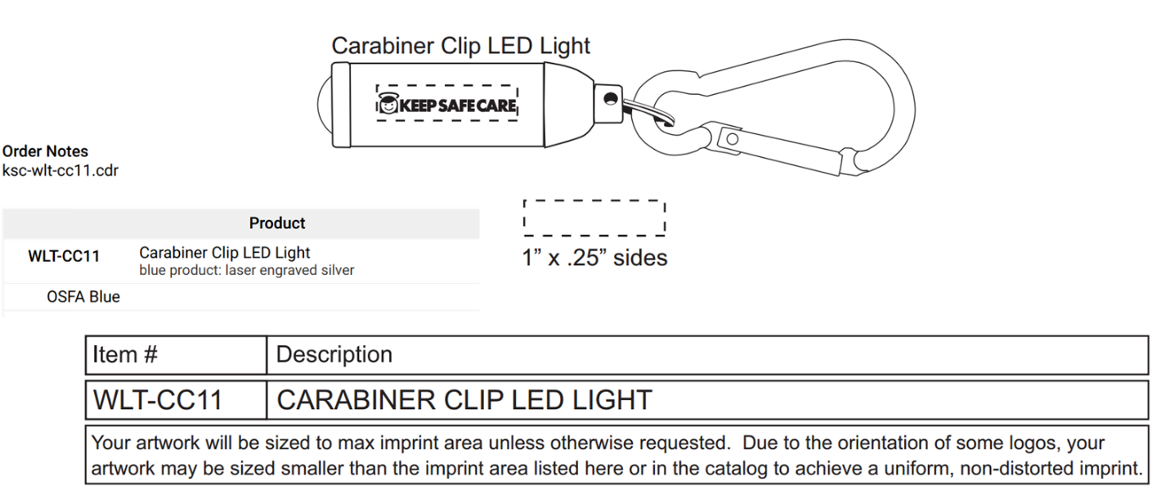

White Metal Logo Pens
These metal pens are order through Totally Promotional (www.totallypromotional.com). The item number is TPEN327, the color white, and the logo color is Reflex Blue.
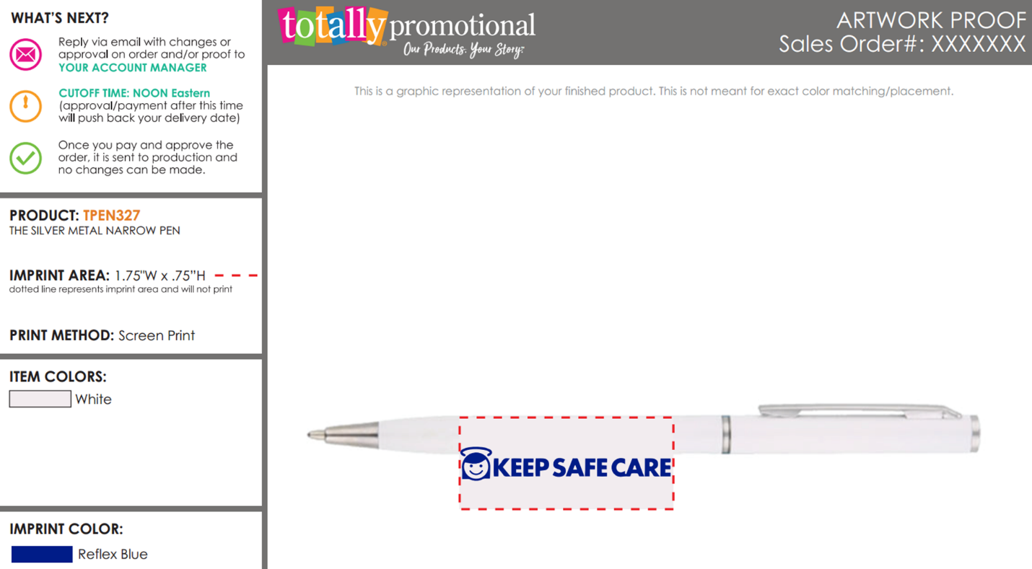

Dry Erase Magnetic Sheets
A great leave behind with your clients is a dry erase magnet with your name, company name, address, and telephone number. This labels have been ordered for your agency already and instructions on how to affix the label is on the follow page. There at 5 sheets in each packet, and it is recommended you order 10 sheets originally.
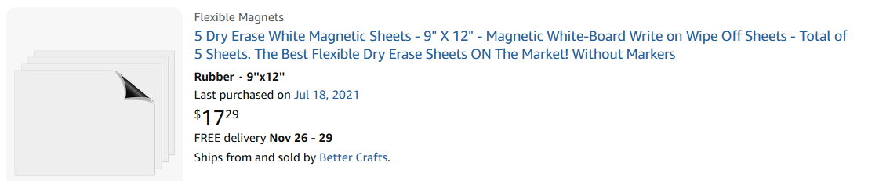
The Amazon URL for these sheets is: https://www.amazon.com/Dry-Erase-White-Magnetic-Sheets/dp/B0123XF47K?th=1

Cutting Instructions for Dry Erase Sheets
When you order the dry erase magnetic sheets, you will notice the come in 9 by 12 inches. You will need cut them into 9 x 6-inch sheets, and then also affix your Affiliate’s label as illustrated below. This label has already been ordered for you through UPrinting.

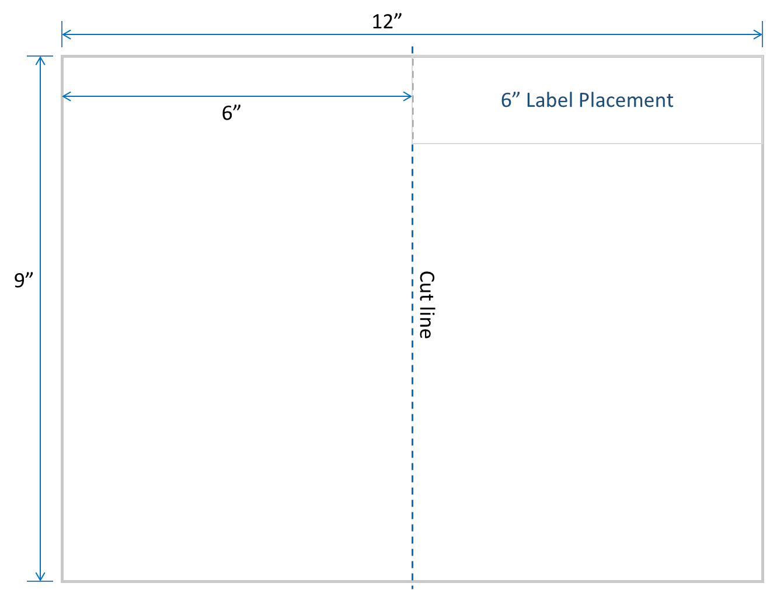
Dry Erase Markers
These markers can be order through Amazon and also have a magnetic top. The URL is https://www.amazon.com/Shuttle-Art-Whiteboard-Whiteboards-Dry-Erase/dp/B07QKHQ7VY/ref=pd_ybh_a_d_sccl_1/136-2266434-0475762?th=1
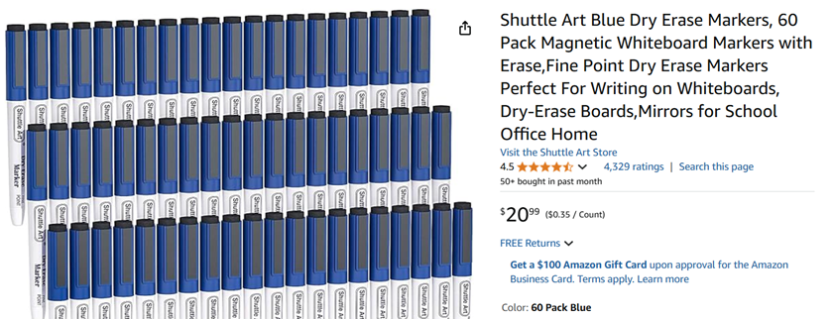

Printed Keep Safe Care Coffee Mugs
These mugs are also procured through Bat City Awards, and are an excellent leave behind not only for clients but for our referral partners, such as Home Health and Hospice agencies. The ordering information is below.

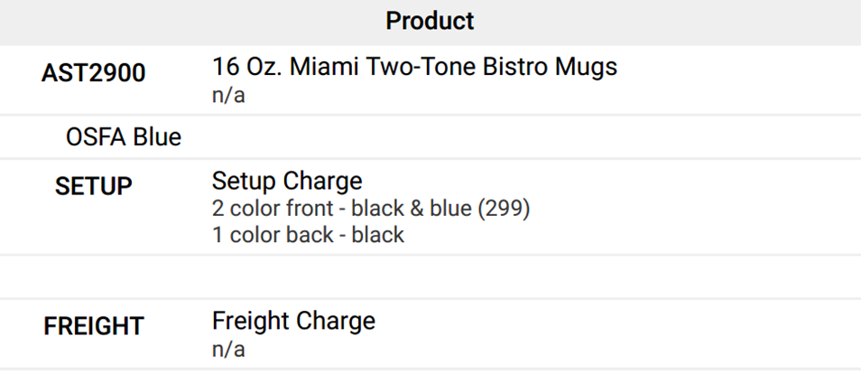

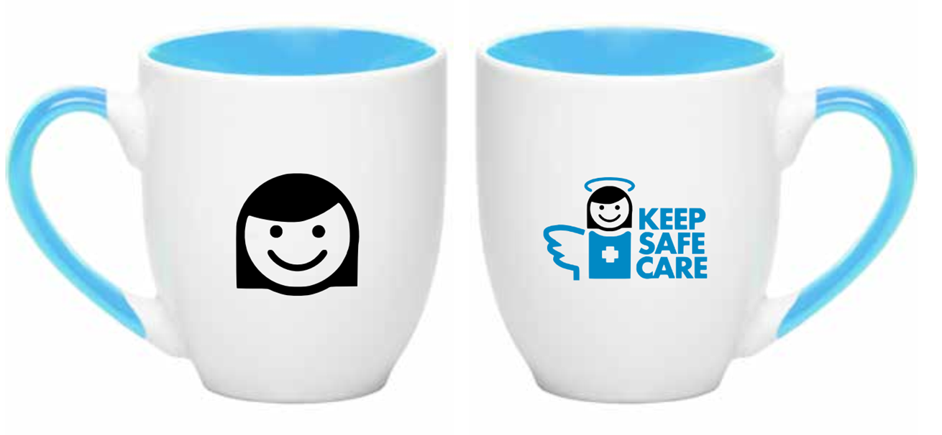

Avery Two Pocket Folders (Dark Blue & Black)
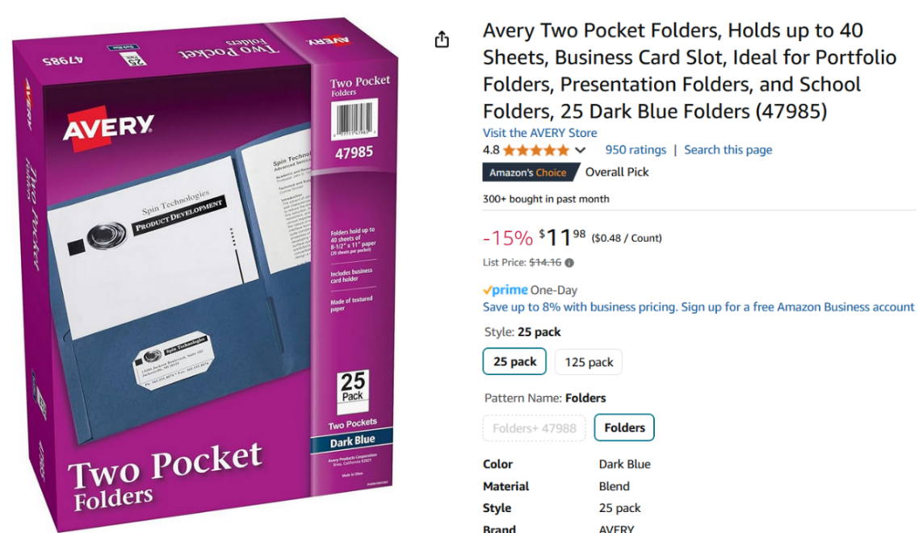
These folders are used when you onboard both Clients and Caregivers. We use different colors to indicate Clients (dark blue) and caregivers (black) to make sure we do not confuse the two. Both can be purchased on Amazon. Remember to affix a label when handing these out.

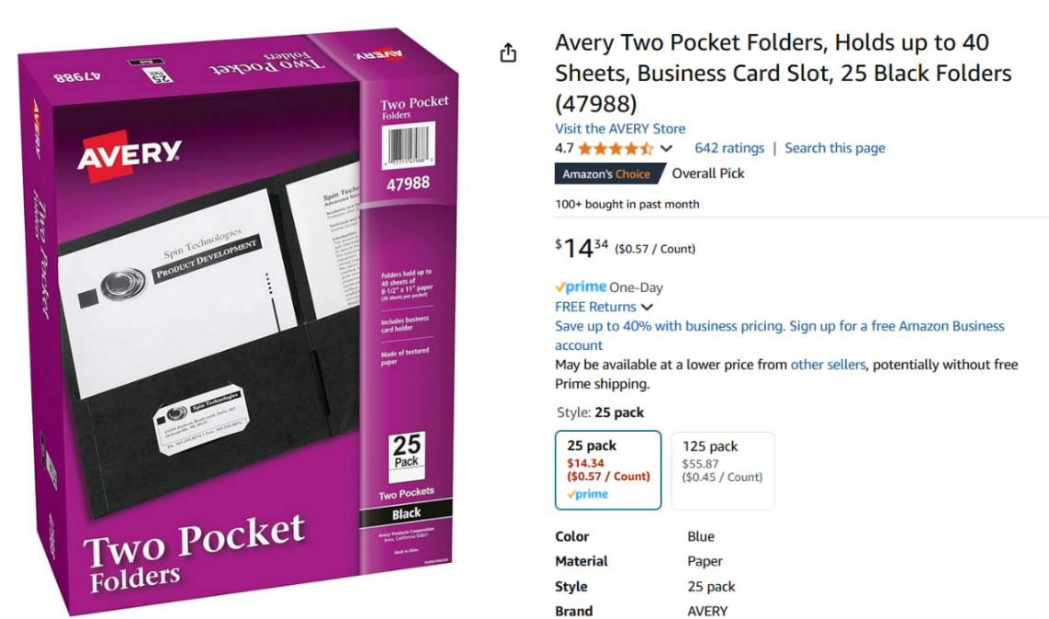
The dark blue URL is https://www.amazon.com/Avery-Two-Pocket-Folders-Dark-47985/dp/B000AN1MFO/ref=sr_1_1

The black URL is https://www.amazon.com/Avery-47988-Two-Pocket-40-Sheet-Capacity/dp/B000EFJGWY/ref=sr_1_1

White or Blue Paper Bags
When we deliver items to clients and referral sources, we usually place the promotional items in a paper bag. You can use either white or blue, both of which can be ordered on Amazon. Remember to affix a Keep Safe Care label to the bags.
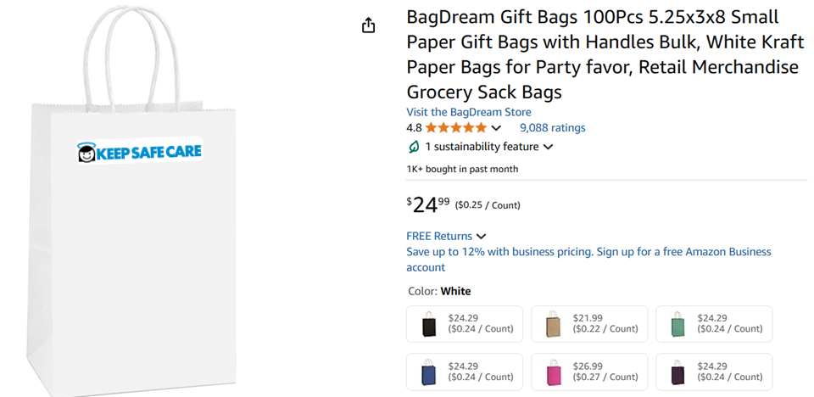
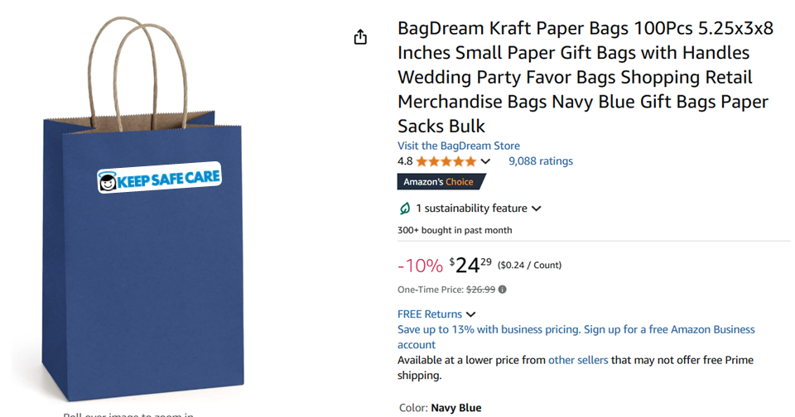
The URL for the white bag is: https://www.amazon.com/BagDream-5-25x3-75x8-Handles-Wedding-Shopping/dp/B01NALTSOP/ref=sxin_16_pa_sp_search_thematic_sspa

The URL for the blue bag is: https://www.amazon.com/BagDream-5-25x3-75x8-Handles-Wedding-Shopping/dp/B08RMJGTQW/ref=sxin_16_pa_sp_search_thematic_sspa

Metal (Aluminum) Etched Name Badges
These name badges are ordered directly through Bat City and delivered to your Agency. There are three basic styles as Illustrated below. You should have the PowerPoint template for each of these badges. These badges are affordable and add a sense of professionalism. Do not order a badge for a caregiver until you are satisfied they will continue to work for your Affiliate.

Owner / Operator Badge
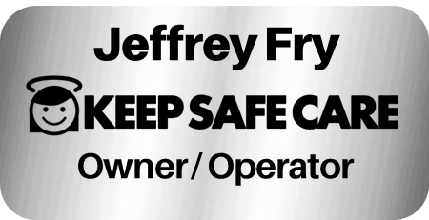

Certified Nursing Assistants (CNAs) Badge
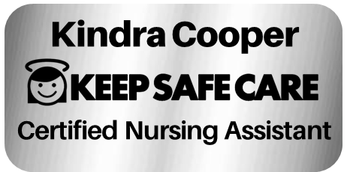

Personal Care Attendants (PCAs) Badge
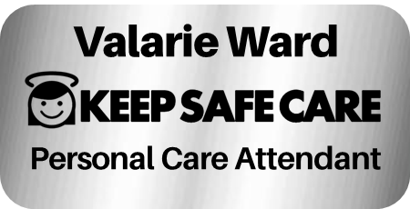

Embroidered Items
All of your embroidered items are done through Bat City Awards. Caregiver tops and baseball caps can be purchased directly through Bat City as shown in the following pages. Other items you want embroidered will need to sent either to Bat City or to their embroidery location.
Embroidery Items

Item | Qty | Ordered | Arrived
Dress Shirts Owners (per owner) | 2
Caregiver Polo, X-Small | 3
Caregiver Polo, Medium | 5
Caregiver Polo, Large | 4
Caregiver Polo, X-Large | 4
Caregiver Polo, 2X-Large | 3
Caregiver Polo, 3X-Large | 2
Black Caps | 12
Scrubs Top Embroidered | 2

Miscellaneous Embroideries
It is recommended that the Owners get an embroidered dress shirt and a set of scrubs for when on occasion they will need to deliver care or do not want to look so formal in a dress shirt.

Embroidered Polo Top
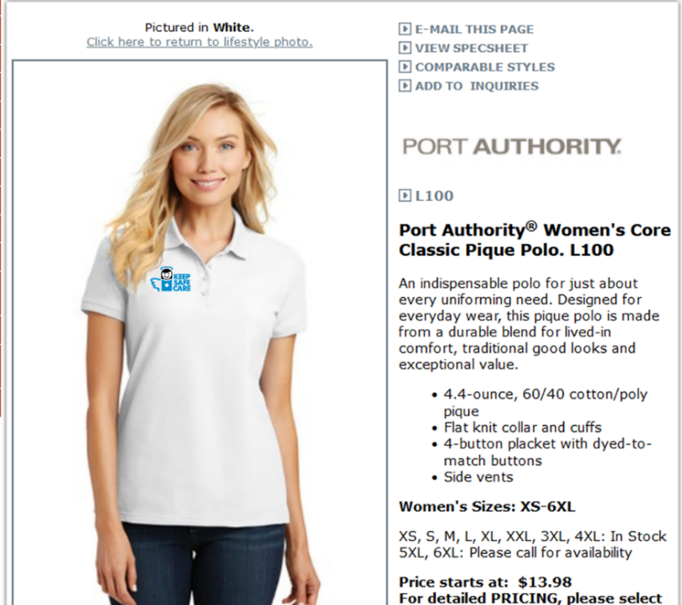
While we do not provide uniforms for our caregivers, we do “reward” them with a nice embroidered polo if they make it through the probation period and they look like they will be consistent, long-term caregivers. The URL for these tops is: https://www.companycasuals.com/batcity/b.jsp?id=13043576&prodimage=imglib/catl/2016/f21/L100_white_model_front_102016.jpg&swatch=White

Embroidered Cap (Black)
These caps are used to give to individuals whom you want to impress with a unique gift. They can include caregivers, partners, friends, and family. These are also ordered through Bat City.
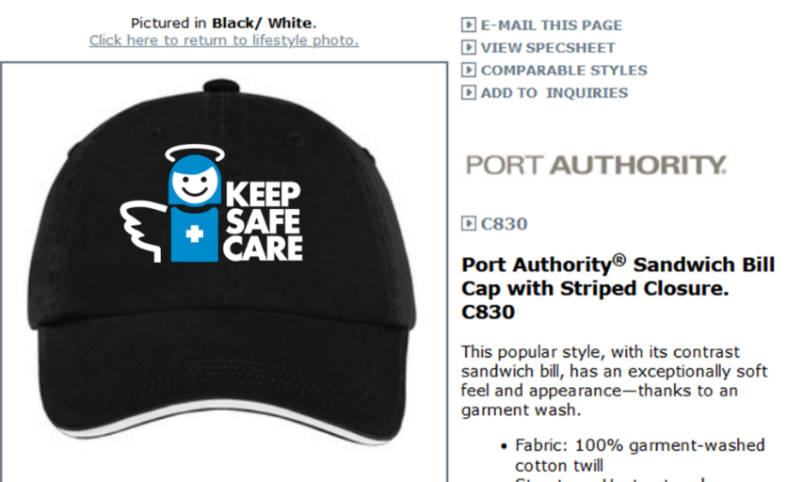

[left intentionally blank]



